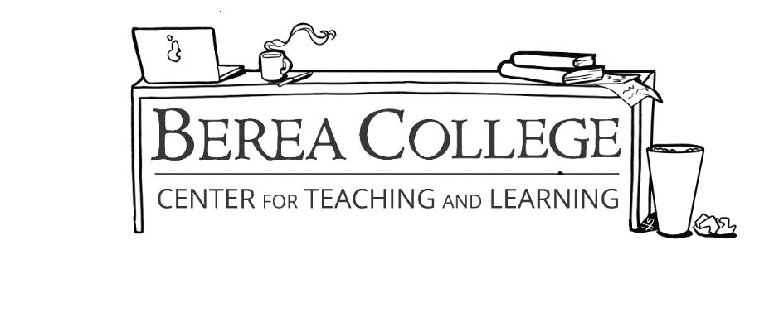

Strategies for **Critical Reading**

Critical reading helps you not only *understand,* but also *evaluate* and *apply* what you read. Here are some practical strategies to get started:

**SKIM** – Look over the text, reading everything in **bold** or *italics* to get an idea of what the text is about. Try to come up with an overall picture of the text's thesis or argument.

**REVERSE OUTLINE** – As you read, take notes of what each section is about. Use the MEAL plan—identify the **Main idea,** the **Evidence** to support the idea, the author's **Analysis** of the evidence, and the **Link** back to the main thesis.

**ASK QUESTIONS** – Take notes of every thought you have while reading. Ask questions like, "What does the author mean by this?" or "Why does this part make me confused/happy/angry/thoughtful/etc?" Mark any place where there are definitions or examples that you don't understand and look up definitions later.

**SUMMARIZE** – Rephrase each section in your own words. Make sure you explain the main argument as well as the important pieces of evidence used. Compare your summary with the original text; did you understand the author's idea? Did you explain the important information?

**EVALUATE** – Consider the text's purpose and evidence. Does the argument make sense? Is the evidence relevant? Are you thinking about this topic in a new way? Why or why not?

**REVIEW** – Look back at the text with new eyes. What did you miss the first time? Are there any parts that make more or less sense now? Why? Did the author persuade you? How?

*Some Tips to Apply These Strategies:*

**UNDERSTAND the AUTHOR'S CONTEXT** – When was this text written? By whom? Why did they write it? What did they hope to accomplish? Understanding the context of the work can help you understand the author's intention in writing it.

**UNDERSTAND YOUR OWN CONTEXT** – What is your own background and perspective? How do your own experiences affect the way you interpret this text? Does it challenge you? Do you agree with it? Why or why not?

**CHECK the EVIDENCE** – Are the author's sources reliable? Is there a good variety of sources? Are they relevant? If you agree with the argument: why? What might make you disagree with it? If you disagree with the argument: why? What might make you agree with it?

**QUESTIONS?**

Some helpful sources for reading critically include *CriticalReading.com* by Dan Kurland and "Reading Critically" by Kent State University (<https://www.kent.edu/stark/reading-critically>). For questions, check with your professor or ask Writing Resources. Create appointments at <https://berea.mywconline.com>, or just stop by for a walk-in consultation!