

**APA Style Tipsheet-7th Edition**

**Format**

When writing an essay in APA, it will always include these four sections:

Remember to always ask your professor for the formatting requirements they would prefer to use for the assignment. Some questions to consider are:

* Does the assignment call for a title page?
* Does the assignment call for an abstract?
* Does your professor prefer headings and subheadings in the body of the essay?

1

Also known as the cover page, a title page is the first page a reader will encounter when reading your essay. The title page should be centered in the upper half of the page and should contain the following components:

Engaging Title of Paper

Your Name

Institution

1. Page number in the top, right corner
2. Title of the essay, your name, and the institution in the upper center
3. **Note:** In the sixth edition of the APA Style, there used to be a “running head” that was found in the upper left corner. It would appear in this location throughout the entire essay, but there is no longer a need to include it in the seventh edition. With this being said, **make sure to ask your professor if they still want you to include this on their assignments**.

An abstract is a 150-250 word, one-paragraph summary of your paper/research. Abstracts have no indentation and the heading (Abstract) should be centered. Your abstract should include the important points of your paper: the topic, the methods, the results or significant findings, keywords, etc. The abstract always goes before your title page and before the body of your paper begins.

The body of your paper should have a strong thesis that serves as a model for the organization of the rest of your essay. APA is most commonly used in science/social science writing, which emphasizes the importance of the date of publication, the publication source, and the credibility of the author(s). **In-text citations** in APA format consist of the **name**, **date**, and **page numbers** of the source, and each element is separated by a comma.

* **Example of in-text citation:** (Forester, 2018, p.18)
* Note: If the author’s name is mentioned within the sentence, include the year in parenthesis immediately after the author’s name and the page number in parenthesis at the end of the sentence. **Example**: Forester (2015) explains that little seagulls are good at citing sources (p. 26).
* **Changes in Seventh Edition That Take Place in Body:**
  + You no longer need to double space after the punctuation of every sentence, which the sixth edition requires.
  + It is recommended in the seventh edition to use “they” when referring to any person who prefers this pronoun or if their gender is unknown/irrelevant to the context of the essay. When using “they,” it is inclusive to all genders and defers students from making conclusions about the gender of the person they are citing.

**Example:** The teacher gave “their” students the assignment sheet for the next essay.

* + Use “quotation marks” instead of *italics* when you are showing a unique example.

**Correct Example:** “Use the singular pronoun ‘they’ to refer to a person who prefers that pronoun or when the gender of the person is ‘unknown or irrelevant to the context of the usage’ (APA, 2020, p. 120).” (Example from LaBate)

* + The seventh edition also changes the in-text citations for sources with three or more authors. You can now use “et al.” for any source that has three or more authors. This is different than the sixth edition, which only allows writers to use “et al.” if a source has six or more authors.

In the Reference List, you give credit to all of the resources you used in your paper. “References” is centered at the top of the page, and the references used in writing your essay are located underneath. Each citation should be left-aligned and formatted with a hanging indent.

**General Reference Format for Book:**

Last Name, First Initial. (Year). *Book title in italics with only the first word*

*capitalized unless punctuated like the following: That colon.* Publisher.

Book Example:

Calfee, R. C., & Valencia, R. R. (1991). *APA guide to preparing manuscripts for journal publication.* American Psychological Association

**General Reference Format for Periodical:**

Last Name, First Initial. (Year). Article title with only the first word capitalized unless

there is punctuation; The first word after this semicolon should be capitalized. *Periodical Title in italics, volume number in* italics (issue number in regular font), pg-range with hyphen. DOI or URL.

Periodical Example with DOI/URL:

Brownlie, D. (2007). Toward effective poster presentations: An annotated bibliography.

*European Journal of Marketing, 41,* 1245-1283.   
doi:10.1108/03090560710821161.

**General Format for Websites:**

Last Name, First. Initial, & Last Name, First Initial (Date of publication). *Title of*

*document.* Retrieved from http://Web address.

Website Example:

Angeli, E., Wagner, J., Lawrick, E., Moore, K., Anderson, M., Soderland, L., & Brizee, A.

(2010, May 5). *General format.* Retrieved from http://owl.english.purdue.edu/owl/resource/560/01/.

**General Format for Online Media:**

Last Name, Initials. [*Twitter* handle or full first name on *Facebook*]. (Year, Month Day).

Title of post *or* Content of post up to 40 words [Name of Platform/Media]. URL

Online Media Example (Facebook Post):

Obama, B. (2016, June 21). This is the only planet we’ve got, and we have to do

everything we can to protect it-- including action to fight climate change [Facebook post]. www.facebook.com/barackobama https://www.facebook.com/USInterior/photos/a.155163054537384/2586475451406120/?type=3&theater

**Changes in Seventh Edition that Take Place in References:**

* You **do not have to include the place of publication** in the reference citations.
* You **have to include issue numbers for** journal citations.
* You **do not have to include “Retrieved from” or “Accessed from”** when using hyperlinks in your reference list. With this being said, you should always make the hyperlinks live so that your professor can access the material through your reference list.

APA Quick Reference

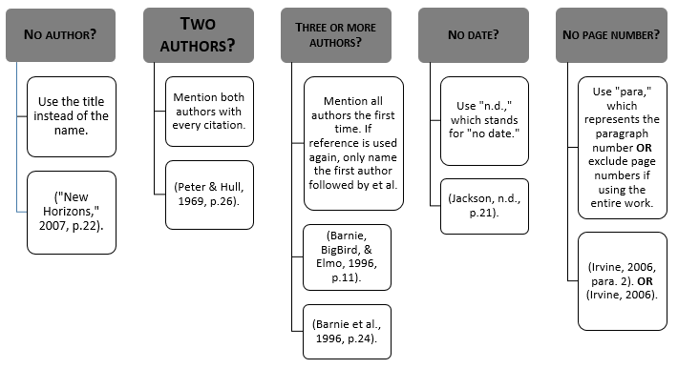

**APA Style Tipsheet References**

Brody, M., Bullock, R., & Weinberg, F. (2017). Write. In The Little Seagull Handbook with Exercises (pp. 1–88). New York: W.W. Norton & Company.

Paiz, J. M., Angeli, E. A., Wagner, J., Lawrick, E., Moore, K., Anderson, M., Soderlund, L., Brizee, A., Keck, R. (2018, February 21 ). APA formatting and style guide. Retrieved from <https://owl.english.purdue.edu/owl/resource/560/01/>.

LaBate, J. (2020). APA changes in new seventh edition. *The Startup*. <https://medium.com/swlh/apa-changes-in-the-new-seventh-edition-4a9d12cec62b>

Our Font Choice, Dyslexie, is designed to ease the reading process for people with dyslexia.   
Updated 03 18 20 CB