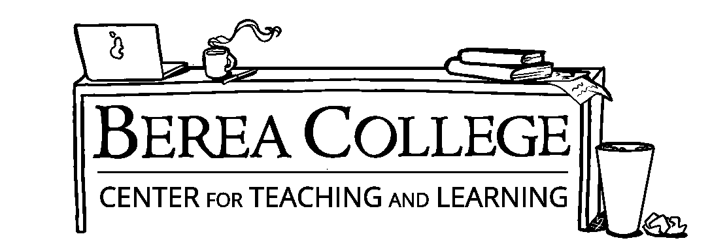

**Personal Statement Tips**

**What is a Personal Statement and what purpose does it serve?**

A personal statement is a document written in the job or graduate school application process that allows you to express your personal strengths without the confines of bullet points, as with a resume. It is sometimes prompted with questions that ask you to explain previous life experience that led you to applying to the program or position and serves as a way for you to establish the goals you would achieve given the opportunity to grow in this position.

**How do I know if I even *need* a personal statement?**

Organizations and educational institutions will ask for personal statements in order to get a better understanding of the individual who is applying. Personal Statements are often instrumental to getting employers and academic committee’s to see your drive and dedication to your field by allowing them to read about your personal story and past experiences in your field of interest.

**What kind of information should I put in a Personal Statement?**

* Your interest in the position being applied for
* Your qualifications
* How you align with the organization or institution’s mission
* How this position can help you reach your career-oriented goals

**Overall Advice When Writing a Personal Statement**

* Answer the questions that the hiring committee of the institution or organization has asked you. As with resumes, you should make each personal statement unique to the job or application you are applying for.
* Tell your personal story in a way that makes you stand out. You want to bring something new to the table, so do this in one of the first impressions: your personal statement!
* Be specific when stating how you would be a good fit for the position. You can do this through explaining specific experiences in your life.
* Make sure you have an opening paragraph that really grabs the reader’s attention and makes them want to continue.
* Communicate what you know about the organization or institution in the paragraphs after the opening. It may be helpful to use language and terms that this field typically uses.
* Remember to avoid certain topics like controversial issues or the accomplishments you have from high school.
* Always do research about the organization, institution, or program. Using some of their missions and goals make you look more knowledgeable and could lead them to accept you!
* Look over your personal statement multiple times, specifically looking for typos or small errors. These can make you look unprofessional and as though you do not care about getting hired.
* Avoid using cliches about the position, institution, or organization you are applying for.

**Some Questions to Think About Before Writing Your Personal Statement**

* What experiences in your life have impacted or set you apart from other possible applicants? (This can include issues you overcame in your family, people or events that may have influenced you and your goals, or some history or insight into your family.)
* What are some traits or characteristics that make you a good fit or make you more successful for this position? Maybe giving some examples of these traits and how you possess them in your life would help.
* When did you become interested in this organization or institution, and what about this program has made you interested in pursuing it? Also, what have you gained in this process?
* What are some of the best and strongest reasons that this institution or organization should accept you?

**What is the format of a Personal Statement?**

As with any application you should **check for specific requests that the organization/institution asks of you,** but generally personal statements are:

* 1-2 pages long (approximately 500 words)
* Double spaced
* 1-inch margins
* Typed in Times New Roman, 12 point font

**Personal Statement Example**

Having majored in literary studies (world literature) as an undergraduate, I would now like to concentrate on English and American literature.

I am especially interested in nineteenth-century literature, women's literature, Anglo-Saxon poetry, and folklore and folk literature. My personal literary projects have involved some combination of these subjects. For the oral section of my comprehensive exams, I specialized in nineteenth century novels by and about women. The relationship between "high" and folk literature became the subject for my honors essay, which examined Toni Morrison's use of classical, biblical, African, and Afro-American folk tradition in her novel. I plan to work further on this essay, treating Morrison's other novels and perhaps preparing a paper suitable for publication.

In my studies toward a doctoral degree, I hope to examine more closely the relationship between high and folk literature. My junior year and private studies of Anglo-Saxon language and literature have caused me to consider the question of where the divisions between folklore, folk literature, and high literature lie. Should I attend your school, I would like to resume my studies of Anglo-Saxon poetry, with special attention to its folk elements.

Writing poetry also figures prominently in my academic and professional goals. I have just begun submitting to the smaller journals with some success and am gradually building a working manuscript for a collection. The dominant theme of this collection relies on poems that draw from classical, biblical, and folk traditions, as well as everyday experience, in order to celebrate the process of giving and taking life, whether literal or figurative. My poetry draws from and influences my academic studies. Much of what I read and study finds a place in my creative work as subject. At the same time, I study the art of literature by taking part in the creative process, experimenting with the tools used by other authors in the past.

In terms of a career, I see myself teaching literature, writing criticism, and going into editing or publishing poetry. Doctoral studies would be valuable to me in several ways. First, your teaching assistant ship program would provide me with the practical teaching experience I am eager to acquire. Further, earning a Ph.D. in English and American literature would advance my other two career goals by adding to my skills, both critical and creative, in working with language. Ultimately, however, I see the Ph.D. as an end in itself, as well as a professional stepping stone; I enjoy studying literature for its own sake and would like to continue my studies on the level demanded by the Ph.D. program. (Stelzer pp. 40-41)

References

Stelzer, R. J. (2002). *How to write a winning personal statement for graduate and professional school*. Lawrenceville, NJ: Thomson/Petersons.

Purdue Writing Lab. (2020). General Format // Purdue Writing Lab. Retrieved from https://owl.purdue.edu/owl/research_and_citation/apa_style/apa_formatting_and_style_guide/general_format.html

Purdue Writing Lab. (2020). “Writing the Personal Statement.” Retrieved from https://owl.purdue.edu/owl/job_search_writing/preparing_an_application/writing_the_personal_statement/index.html