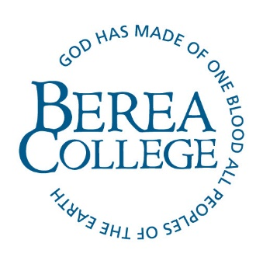
Request for Information - Single Room Documentation Form
Student’s Name: ____________________________________________________________
B-Number: ___________________________________________
Berea College is committed to providing reasonable accommodations to students with disabilities. The ADA defines a disability as a “physical or mental impairment that substantially limits one or more major life activities”. This document is designed to assist us in determining whether the above-named student requires a single room for reasons of disability under the ADA.
The residential hall experience is an integral component of a Berea College education. Part of this experience is shared living space. While we recognize that a single room may benefit someone with a significant disability, the limited amount of single rooms available make it necessary to carefully consider each request. Please explore all treatment options that might mitigate the barriers of a shared housing placement.
The following is to be completed by a licensed healthcare provider
Diagnosis (ICD-10 or DSM-5): ______________________________________________________________
Level of Severity: _________________________________________
Date of diagnosis: ____________________________
Describe the professional relationship with this student. How long have you been working with her/him/them? _________________________________________________________________________________________________________________________________________________________________________________________________________________________________________________________
Does the impairment substantially limit one or more major life activities? ☐ Y ☐ N
If yes, describe the impaired major life activities: _________________________________________________________________________________________________________________________________________________________________________________________________________________________________________________________
Treatment options, medications, required medical or assistive devices, and/or services, if any: _________________________________________________________________________________________________________________________________________________________________________________________________________________________________________________________
Presenting symptoms and/or functional limitations in the residential setting - please be detailed: _________________________________________________________________________________________________________________________________________________________________________________________________________________________________________________________
Is there another intervention or treatment that you could recommend that might be a reasonable alternative to having a Single Room? _________________________________________________________________________________________________________________________________________________________________________________________________________________________________________________________
By submitting this form, the student has given Disability & Accessibility Services permission to contact you if we have any further questions. Please contact us for any questions you may have. Thank you!
Professional’s Signature: ______________________________________________________________
Printed Name & Credentials: ________________________________________________________________
License #: _______________________________________________
Address: _____________________________________________________________________
City: ________________________________________State: __________Zip: _________________
Telephone: ____________________________
Date: _____________________________
Return this information, marked confidential to:
Berea College, Disability & Accessibility Services
110 Lincoln Hall, CPO 2205
Berea, KY 40404
Phone: 859-985-3237
Fax: 859-985-3921
Email: hatfieldh2@berea.edu

