BOR Meeting 02/24/2019
Attendance: All are present in meeting
- Transition of Power – James Hall
  - Aloyce Riziki has stepped down from James Hall President due to commitment conflicts and other external factors.
  - James Vice President Jacob Walker intends to step up as James Hall President.
    - Motion by Chase, seconded by Chris
    - Motion passed; Jacob new President representative for James Hall
- Resignation – Elizabeth Rogers Hall
  - Vice President of Elizabeth Rogers has been contacted, but was not present at the meeting.
  - Motion to confirm resignation of Allison Collins as Elizabeth Rogers Hall President passed; Elizabeth Rogers will have no representation until confirmation of new president.
- Appointment of New Clerk
  - Chase Denny nominates himself to take over the duties of Clerk after the resignation of Allison Collins.
  - Motion to confirm passed; Chase will assume duties of Clerk at next meeting.
- Articles of Impeachment – Lakshya Bharadwaj
  - A reminder to the Board: the duties of the Board in the impeachment process is simply to acknowledge the points and decide if the evidence is appropriate to bring to the Senate.
  - Article 1:
    - 5 counts of Malfeasance, misfeasance, and misconduct.
    - Vacancy in the Judiciary
      - Subpoint 1:Mislead the Executive Council, Montana Hite, members of the Judiciary board and/or Ash Dodwani
      - Subpoint 2: Regarding a violation of Confidentiality
        - Called for removal for confidentiality within the Judiciary body. (impeachment of Cole Dutton)
        - Ash Dodwani was not removed so was entitled to information
      - Subpoint 3: Misleading the cancellation of BOR elections
        - Misinformed Ms. Hite about the vote into BOR elections
          - Did not have quorum because of there only being 3 members.
      - Subpoint 4: Misinforming about Judiciary Chair
      - Subpoint 5: Possession of minutes
        - Claimed had minutes, but when asked for the minutes about Ash not being a member of the Judiciary
  - Article 2: Failed as Executive Chief to give due process
    - Regarding Impeachment of Ash Dodwani
      - Ash was recognized as on the Judiciary Board, then after a brief argument with Lakshya, moved incorrectly to impeach Ash Dodwani, violating due process.
      - Ash was informed that through a Facebook post that her seat was vacant.
  - Article 3: Getting adequate consent from the Senate
    - Parliamentarian of Senate and Speaker of the Senate that there was a vacant seat in the Judiciary Board and that he had decided on someone (Seth Louis) to take over that position.
    - Needed to bring up the impeachment of Ash and the approval of Seth Louis in the Judiciary Board.
  - Article 4: Misconduct: refusing to follow instructions to be non-partisan
    - Statement that he had to inform the students about the political situations
    - Could have Jeopardized the non-profit status of the college.
    - Amy Mcgrath was invited by Lakshya but did not invite the other candidate, but was made to by the college.
  - Clarifications:
    - Lakshya has no right to be partisan under VEPAC and the non-profit college to be non-partisan.
  - Closing: Lakshya has undermined SGA by his actions informed by the above articles.

  - Motions:
    - Motion to fail Article 1 as a valid Article of Impeachment
      - Motion passed, 5-1-0.
    - Motion to pass Article 2 as a valid Article of Impeachment
      - Motion passed unanimously
    - Motion to pass Article 3 as a valid Article of Impeachment
      - Motion passed unanimously
    - Motion to fail Article 4 as a valid Article of Impeachment
      - Motion passed unanimously

- Funding Requests:
  - Dana Hall: White boards.
    - Asking for: $88.37
      - Motion to pass full amount
      - Motion passed
  - Bingham Hall: Painting and face masks
    - Asking for: $125
      - Motion to pass full amount
      - Motion passed

- Decisions Made by the Board of Residents Post-Meeting – Addendum
- The Board has agreed to include Addendum Documents 1A-D, which include email correspondence between Board of Residents Chair Montana Hite and SGA Advisor Gus Gerassimides. The Board of Residents, President Lyle Roelofs, Gus Gerassimides, Elston Harris, Ishara Nanayakkara and Elizabeth Miller were copied in this email addressed to Executive President Lakshya Bharadwaj. These documents entail the full correspondence by all parties involved.

Document 1A – Email from Board of Residents Chair Montana Hite addressed to SGA Executive President Lakshya Bharadwaj detailing results of initial impeachment hearings.

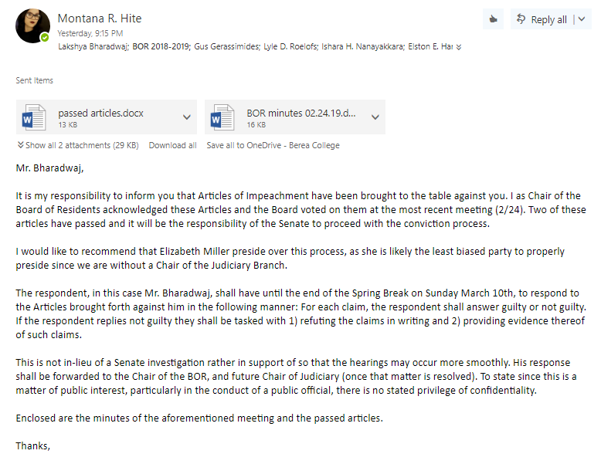

Document 1B – Response from SGA Advisor Gus Gerassimides to Board of Residents Chair Montana Hite detailing the involvement of the Student Life Council in the aforementioned impeachment process (1 of 2).
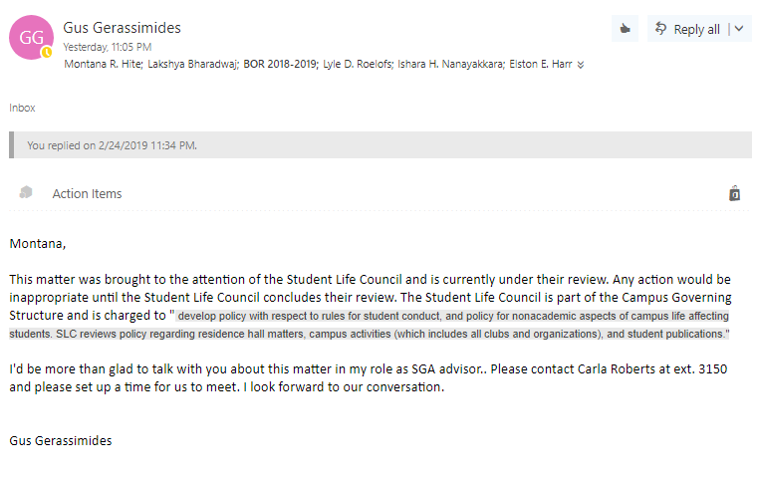

Document 1C – Response from Board of Residents Chair Montana Hite to SGA Advisor Gus Gerassimides stating the involvement of SGA in its own impeachment process.
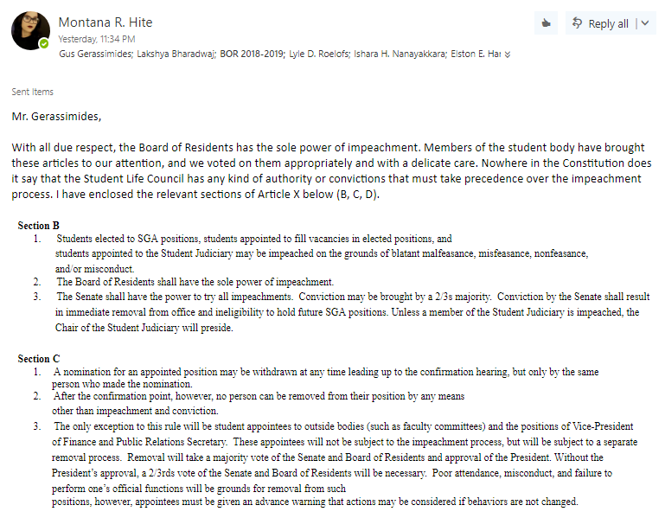
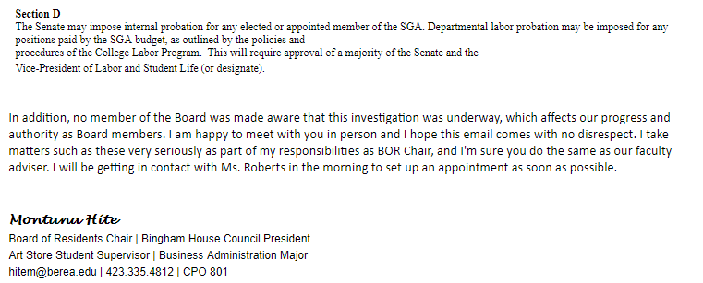
Document 1D – Response from SGA Advisor Gus Gerassimides to Board of Residents Chair Montana Hite detailing the involvement of the Student Life Council in the aforementioned impeachment process (2 of 2).
