Looking for a MAY TERM class? Check out Professor Malaklou’s “Gender, Sexuality, and BLM” course, which meets MTWRF 10AM – 12:30PM in Draper 106.  COURSE DESCRIPTION:  Students will ask questions like: Do black lives matter? Can life matter if it is black? How is black life that doesn’t matter sexed and/or gendered?  WHAT STUDENTS SAY:  “I learned so much in this course and…it has helped me become […] better at thinking diversely and critically. I can honestly say that I feel like this course made me a better person.”  “I had no idea what this course would be like when I started. It ended up being one of the most interesting and stimulating classes I have taken this semester.” | - ---------- INTRODUCING ----------  COLLOQUIUM series  Join us once a month for a brown bag lunch between 12-1pm in Draper 106 to discuss:  Feb. 12: Changes to the WGS curriculum  March 25: Insight from the first WGS graduate  April 8: Feminist entrepreneurship and empowerment  Evening with an activist series  Join us for the first ‘Evening with an Activist’ event featuring Berea College student Azis Toktobaev, who will speak about queer activism in Kyrgyzstan.  February 19th 5-6pm in Draper 106
Stop by WGS to pick up your pronoun buttons!
DID YOU KNOW: We’re now a Women’s and Gender Non-Conforming Center! Visit us Mondays, Tuesdays and Thursdays 9AM – 4PM, and Wednesdays and Fridays 9AM – 3PM.

contact us

LOCATION: Draper Building, Room 106
PHONE: 859-985-3217
EMAIL: saderholmk@berea.edu
Dr. M. Shadee Malaklou
Assistant Professor and Chair

Dr. Malaklou’s research examines how gender and sexuality are produced through antiblack racism, or through the exclusion of black people from humanist space-time. In addition to writing for academic journals, she publishes think pieces, most recently, in The Feminist Wire and CounterPunch. Prior to joining Berea College, Dr. Malaklou served as Assistant Professor and Acting Chair of Critical Identity Studies at Beloit College, where she was also a Mellon Faculty Fellow for the Associated Colleges of the Midwest. Dr. Malaklou teaches the capstone course in WGS as well as the elective Gender, Sexuality and BLM.

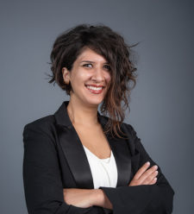

------------------------------ Berea coLLEGE ------------------------------

wOMEN & GENDER’S STUDIES

February 2020 newsletter

2019 STUDENT PROGRAMMERS:
Megan Markert is a junior majoring in TAD. During her time as a WGS student programmer, Megan designed our logo and pronoun buttons.
Interested in working with WGS? Contact Kimberly Saderholm (saderholmk@berea.edu) to inquire about May Term 2020 and Fall 2020 student labor opportunities!
Mandy is a junior majoring in Sociology and minoring in WGS. She is originally from rural southern Indiana and joined the WGS team in Fall 2019. After graduation, Mandy aspires to become a librarian who connects people in poverty to the resources that they need; and to eventually pursue a master’s degree in Library Sciences.

Mandy
Snowden

Student programmer

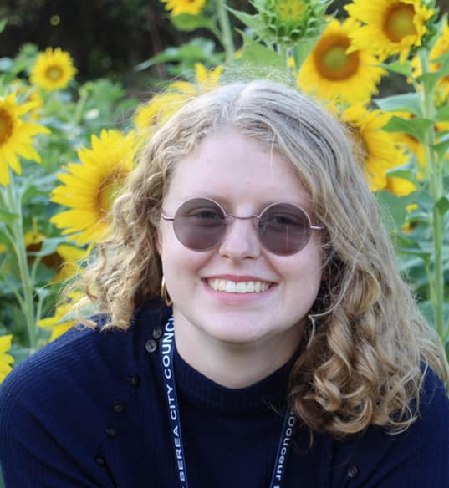
Kimberly Saderholm

Administrative Assistant

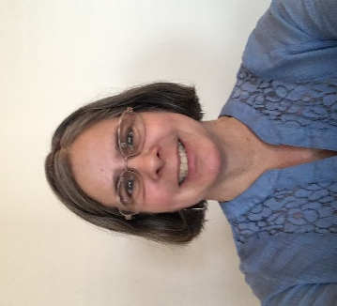
Kim is in her third year as the administrative assistant of WGS. She’s a Buckeye who found her way to Kentucky and graduated from Berea College in 1989 with a degree in Agriculture/Horticulture.

Makayla Allison

Student programmer

Makayla is a senior majoring in Peace and Social Justice and minoring in Law, Ethics and Society. She is originally from Columbus, Ohio and joined the WGS team in Fall 2019. After graduation, she aspires to work with underprivileged students, or to join Teach for America or the Peace Corps.

Dr. Caruthers’ research examines humor, affect, black feminism, queer theory, visual culture, and generational black aesthetics. Some of her analytic musings can be found on The Feminist Wire, Racialicious.com, and academic journals. She teaches Black Feminist theory.
*Dr. Caruthers is also Assistant Professor and Chair of AFR.

Dr. Jakeya Caruthers
Assistant Professor*

Dr. Lee’s research examines the role that (anti)blackness played in the creation of the wrong body narrative and continues to play in our current understanding of transsexuality and transgender identity. In addition to teaching Introduction to WGS, they teach the Institutionalization of Trans and Queer Studies and Feminist and Queer Dis/Ability Studies.

Dr.
Meredith
Lee

Assistant Professor

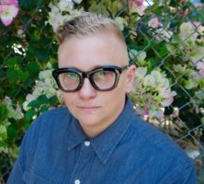
Aku is a senior majoring in Sociology. She is originally from Atlanta, Georgia, but is also half Nigerian and Ghanaian. Aku joined the WGS team in Spring 2020. After graduation, she aspires to work as a youth outreach coordinator back home in Georgia, and later, to pursue a master’s degree in public policy and administration.

Aku
Fiagbeto

Student programmer

